Web API

🌐 What Is a Web API?
# Source: AI Source: Provided by: [Data Path: Persons Table -> ID Column: 1, Name_En Column: Motasem Essam] -> From: [ChatGPT] on [1/19/2026]
A Web API is an API that’s accessible over the internet using web protocols, usually HTTP or HTTPS.

🧠 In Simple Terms:
# Source: AI Source: Provided by: [Data Path: Persons Table -> ID Column: 1, Name_En Column: Motasem Essam] -> From: [ChatGPT] on [1/19/2026]
Web API = A way for applications to communicate over the web.
It allows different software systems—like websites, mobile apps, or servers—to exchange data and services through web requests.

✅ Key Features of Web APIs
# Source: AI Source: Provided by: [Data Path: Persons Table -> ID Column: 1, Name_En Column: Motasem Essam] -> From: [ChatGPT] on [1/19/2026]
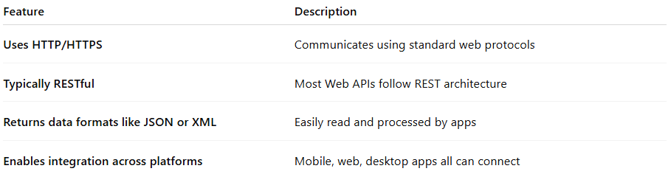

Feature | Description
Uses HTTP/HTTPS | Communicates using standard web protocols
Typically RESTful | Most Web APIs follow REST architecture
Returns data formats like JSON or XML | Easily read and processed by apps
Enables integration across platforms | Mobile, web, desktop apps all can connect

🔰 Common Types of Web APIs:
# Source: AI Source: Provided by: [Data Path: Persons Table -> ID Column: 1, Name_En Column: Motasem Essam] -> From: [ChatGPT] on [1/19/2026]
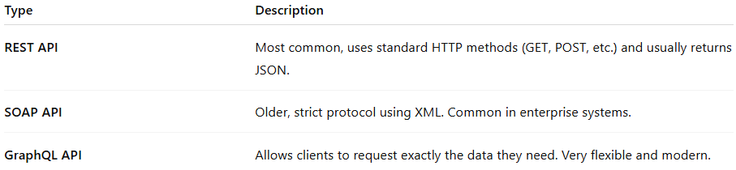

Type | Description
REST API | Most common, uses standard HTTP methods (GET, POST, etc.) and usually returns JSON.
SOAP API | Older, strict protocol using XML. Common in enterprise systems.
GraphQL API | Allows clients to request exactly the data they need. Very flexible and modern.

🧩 Other Types of Web APIs:
# Source: AI Source: Provided by: [Data Path: Persons Table -> ID Column: 1, Name_En Column: Motasem Essam] -> From: [ChatGPT] on [1/19/2026]

Here are more examples that fall under Web APIs:
📦 Open APIs (Public APIs)
- Freely available for anyone to use.
- Example: GitHub API, OpenWeatherMap API, Twitter API
🔒 Private APIs
- Used internally within a company.
- Example: An internal HR system API that employees use.
🤝 Partner APIs
- Shared with specific partners, not the public.
- Example: A payment processor shares APIs with its merchant partners.
🌐 Browser APIs
- Built into web browsers for use in JavaScript.
- Example:
  - fetch() (to make HTTP requests)
  - Geolocation API
  - Web Storage API
  - WebRTC (for real-time communication)

🔧 Example Use Case
# Source: AI Source: Provided by: [Data Path: Persons Table -> ID Column: 1, Name_En Column: Motasem Essam] -> From: [ChatGPT] on [1/19/2026]
A travel app uses a Web API to fetch flight information from an airline.
A website displays Twitter posts by calling the Twitter Web API.
A weather website calls a weather Web API to get real-time forecasts.

🆚 Web API vs Regular API
# Source: AI Source: Provided by: [Data Path: Persons Table -> ID Column: 1, Name_En Column: Motasem Essam] -> From: [ChatGPT] on [1/19/2026]
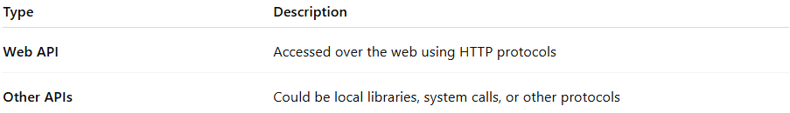

Type | Description
Web API | Accessed over the web using HTTP protocols
Other APIs | Could be local libraries, system calls, or other protocols

APIs for developers Image
# Source: Table Source: Provided by: [Data Path: Persons Table -> ID Column: 1, Name_En Column: Motasem Essam] From: [Data Path: Miscellaneous Folder -> Miscellaneous Database -> Miscellaneous Table -> ID: 26] on [1/19/2026]
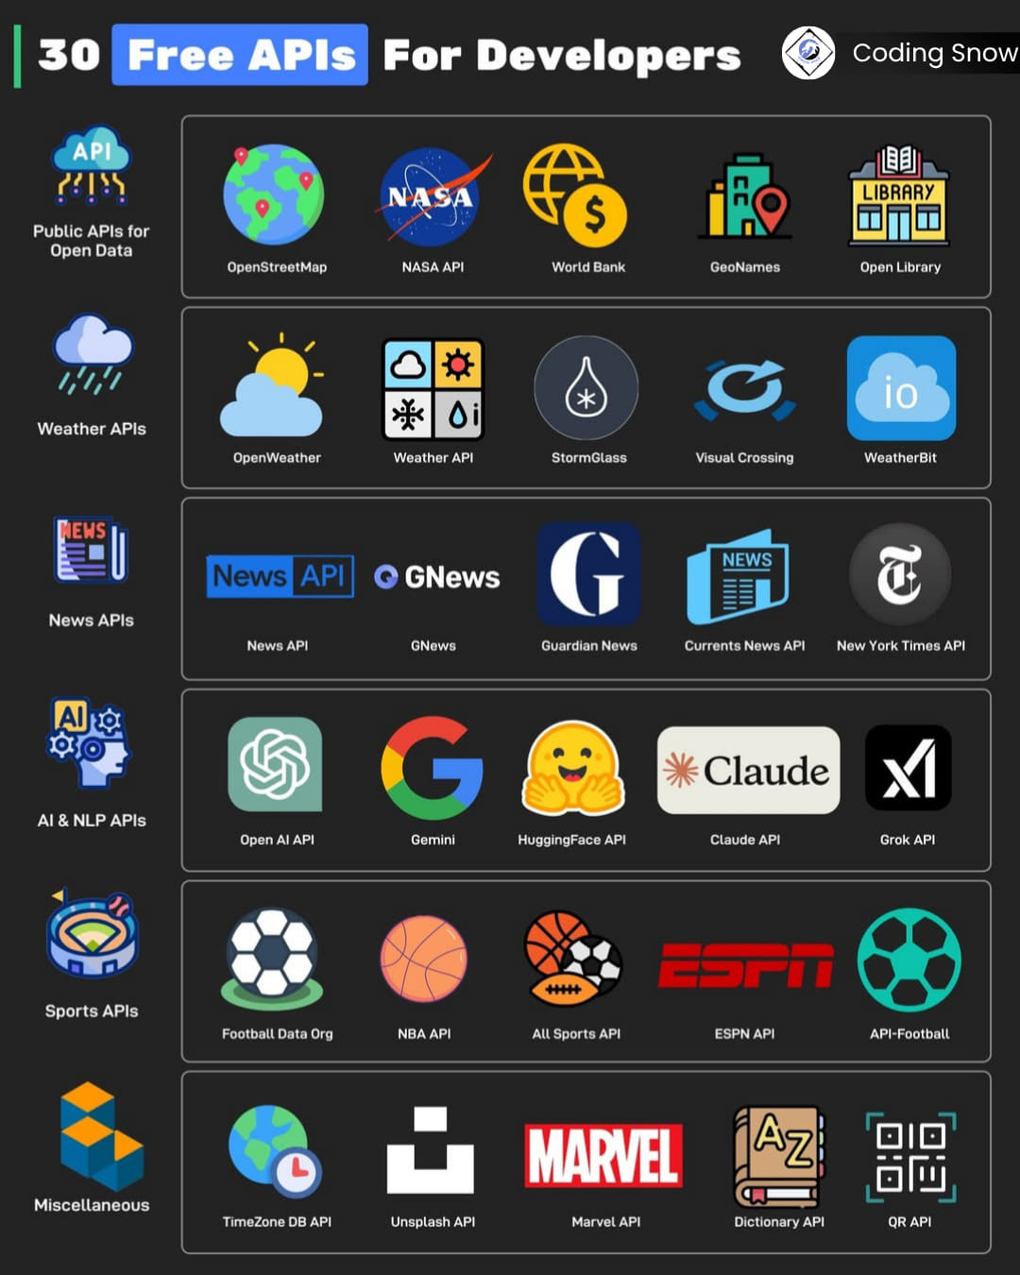

Summary
# Source: AI Source: Provided by: [Data Path: Persons Table -> ID Column: 1, Name_En Column: Motasem Essam] -> From: [ChatGPT] on [1/19/2026]
A Web API is an API accessible via the internet that allows different apps and services to talk and share data using web protocols like HTTP.

